***Solution*** ***Section* 1.4 – Volumes by Shells**

***Exercise***

Use the shell method to set up and evaluate the integral that gives the volume of the solid generated by revolving the plane region about the : 

***Solution***

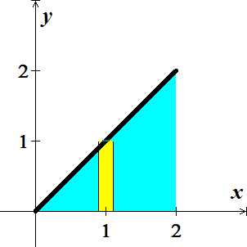 







***Exercise***

Use the shell method to set up and evaluate the integral that gives the volume of the solid generated by revolving the plane region about the  

***Solution***

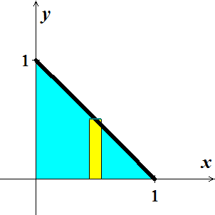 









***Exercise***

Use the shell method to set up and evaluate the integral that gives the volume of the solid generated by revolving the plane region about the  

***Solution***

 

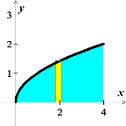 







***Exercise***

Use the shell method to set up and evaluate the integral that gives the volume of the solid generated by revolving the plane region about the  

***Solution***



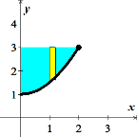 









***Exercise***

Use the shell method to set up and evaluate the integral that gives the volume of the solid generated by revolving the plane region about the 



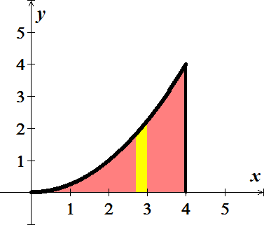***Solution***

 







***Exercise***

Use the shell method to set up and evaluate the integral that gives the volume of the solid generated by revolving the plane region about the 



***Solution***

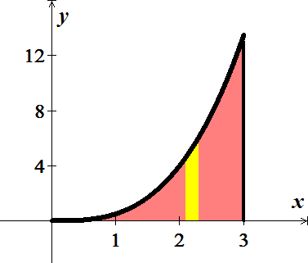 







***Exercise***

Use the shell method to set up and evaluate the integral that gives the volume of the solid generated by revolving the plane region about the 



***Solution***



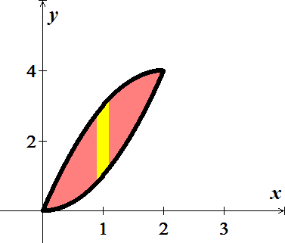

 









***Exercise***

Use the shell method to set up and evaluate the integral that gives the volume of the solid generated by revolving the plane region about the 



***Solution***





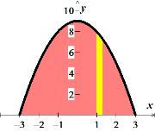 









***Exercise***

Use the shell method to set up and evaluate the integral that gives the volume of the solid generated by revolving the plane region about the 



***Solution***

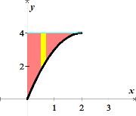



 









***Exercise***

Use the shell method to set up and evaluate the integral that gives the volume of the solid generated by revolving the plane region about the 



***Solution***



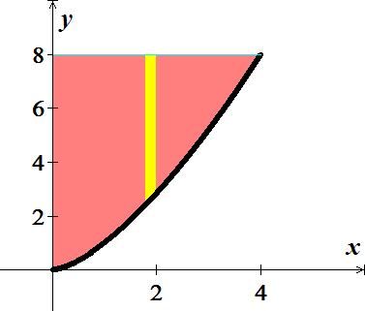

 









***Exercise***

Use the shell method to set up and evaluate the integral that gives the volume of the solid generated by revolving the plane region about the 



***Solution***

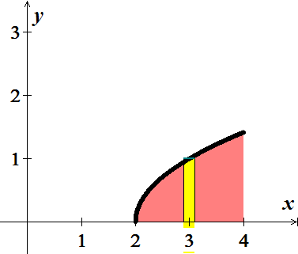



 

 













***Exercise***

Use the shell method to set up and evaluate the integral that gives the volume of the solid generated by revolving the plane region about the 



***Solution***

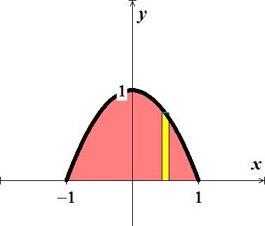



 









***Exercise***

Use the shell method to set up and evaluate the integral that gives the volume of the solid generated by revolving the plane region about the 

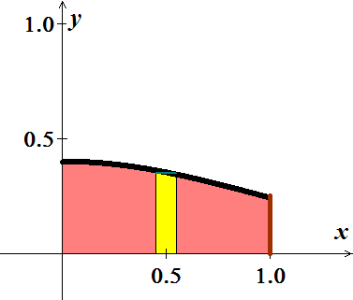 

***Solution***



 









***Exercise***

Use the shell method to find the volume of the solid generated by revolving the shaded region about the indicated axis

***Solution***

 

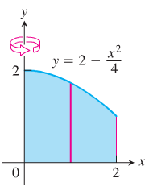 







***Exercise***

Use the shell method to find the volume of the solid generated by revolving the shaded region about the indicated axis

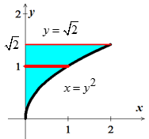***Solution***









***Exercise***

Use the shell method to find the volume of the solid generated by revolving the shaded region about the *y*-axis

***Solution***

 

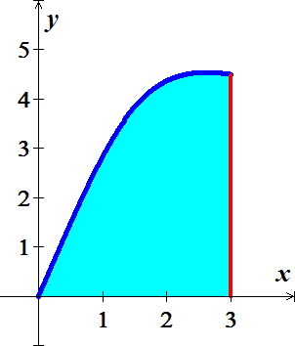 

 

 





***Exercise***

Use the shell method to find the volume of the solid generated by revolving the region bounded by the curve and lines  about the *y*-axis.

***Solution***

 

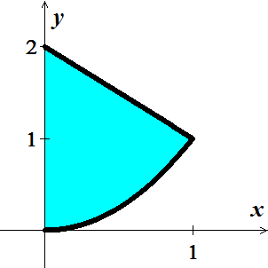 











***Exercise***

Use the shell method to find the volume of the solid generated by revolving the region bounded by the curve and lines  about the *y*-axis.

***Solution***



Since 

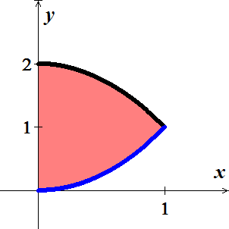













***Exercise***

Use the shell method to find the volume of the solid generated by revolving the region bounded by the curve and lines  about the *y*-axis.

***Solution***

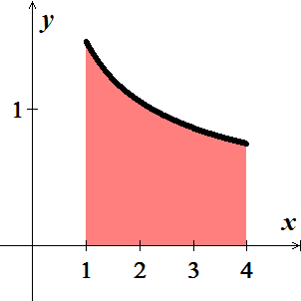













***Exercise***

Let 

1. Show that 
2. Find the volume of the solid generated by revolving the shaded region about the *y*-axis.

***Solution***

1.  

Since  



1.  

 











***Exercise***

Use the shell method to find the volume of the solid generated by revolving the region bounded by the curve and lines  about the *x*-axis.

***Solution***



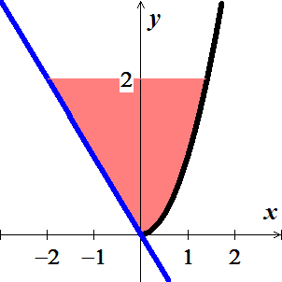













***Exercise***

Use the shell method to find the volume of the solid generated by revolving the region bounded by the curve and lines  about the *x*-axis.

***Solution***

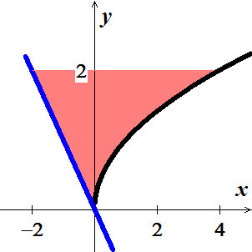















***Exercise***

Use the shell method to find the volumes of the solids generated by revolving the shaded regions about the *indicated* axes.

1. The *x*-axis
2. The line *y* = 1
3. The line 
4. 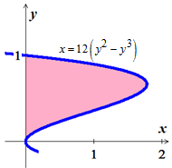The line 

***Solution***

1. 











1. 













1. 















1. 













***Exercise***

Compute the volume of the solid generated by revolving the region bounded by the lines  about each coordinate axis using

1. The *shell* method
2. The *washer* method

***Solution***



1. ***x-axis***

 









***y-axis***

 

 







1. ***x-axis*** 











***y-axis*** 











***Exercise***

Use the *washer* method to find the volume of the solid generated by revolving the region bounded by the curve and lines  about

1. the *x*-axis
2. the *y*-axis
3. the line *x* = 4
4. the line *y* = 1

***Solution***

1. ***x-axis***

 









1. ***y-axis***

 









1. the line *x* = 4

 









1. the line *y* = 1

 











***Exercise***

Find the volume of the solid generated by revolving the region bounded by  and the lines  about

|  |  |
| --- | --- |
| 1. the *x*-axis; 2. the *y*-axis; | 1. the line *x* = 2; 2. the line *y* = 4. |

***Solution***





1. 













1. 













1. 













1. 





















***Exercise***

The region in the first quadrant that is bounded by the curve , on the left by the line , and below by the line *y* = 1 is revolved about the *y*-axis to generate a solid. Find the volume of the solid by

1. The *shell* method *b)* The *washer* method

***Solution***

1. The *shell* method











1. The *shell* method















***Exercise***

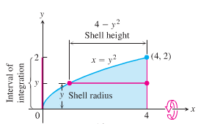The region bounded by the curve , the *x*-axis, and the line *x* = 4 is revolved about the *x*-axis to generate a solid. Find the volume of the solid.

***Solution***





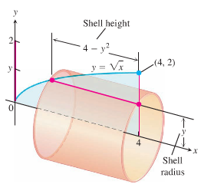 







***Exercise***

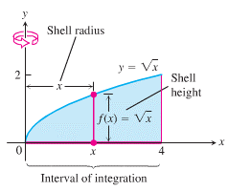The region bounded by the curve , the *x*-axis, and the line *x* = 4 is revolved about the *y*-axis to generate a solid. Find the volume of the solid.

***Solution***

 

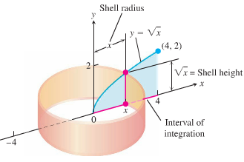 







***Exercise***

Find the volume of the solid generated by revolving the region bounded by  and the lines  about the line *y =* 2.

***Solution***

About line 















***Exercise***

A cylinder hole with radius *r* is drilled symmetrically through the center of a sphere with radius *R*, where . What is the volume of the remaining material?

***Solution***

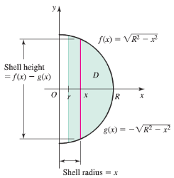 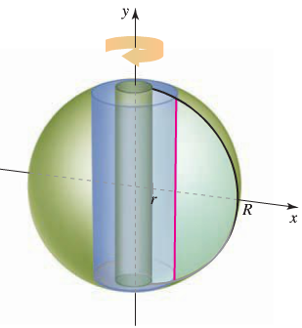

Let *D* be the region in the *xy-*plane bounded above by , the upper half of the circle of radius *R*, and bounded below by , the lower half of the circle of radius *R*, for .

The radius of a typical shell is *x*. Height is 









***Exercise***

Use the shell method to find the volume of the solid generated by revolving the region bounded by the curve and lines  about the *x*-axis.

***Solution***





***Given***: 

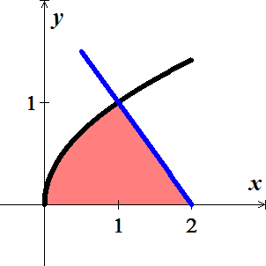











***Exercise***

Find the volume of the region bounded by  revolved about the 

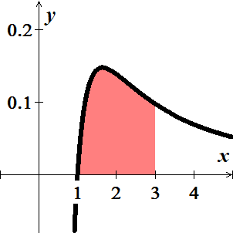***Solution***









***Exercise***

Find the volume of the region bounded by  revolved about the 

***Solution***









***Exercise***

Find the volume of the region bounded by  revolved about the 

***Solution***













***Exercise***

The profile of a football resembles the ellipse. Find the football’s volume to the nearest *cubic* *inch*.

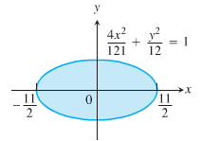

***Solution***

























***Exercise***

Find the volume using both the disk/washer and shell methods of

 revolved about the 

***Solution***

Using ***washers***:





 













Using ***Shells***:



 















***Exercise***

Find the volume using both the disk/washer and shell methods of 

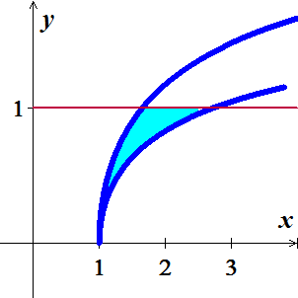revolved about the 

***Solution***

Using ***washers***:









 



 











Using ***Shells***:





 











***Exercise***

Find the volume using both the disk/washer and shell methods of  revolved about the 

***Solution***

Using ***washers***:

















Using ***Shells***:





 











***Exercise***

Use the shell method to find the volume of the solid generated by the revolving the plane region about the given line



***Solution***

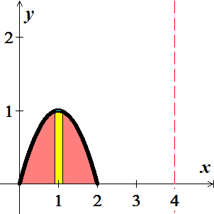



 









***Exercise***

Use the shell method to find the volume of the solid generated by the revolving the plane region about the given line



***Solution***

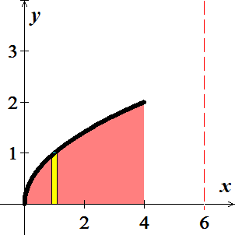



 









***Exercise***

Use the shell method to find the volume of the solid generated by the revolving the plane region about the given line



***Solution***





 

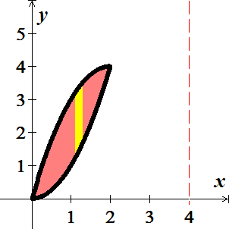 









***Exercise***

Use the shell method to find the volume of the solid generated by the revolving the plane region about the given line



***Solution***





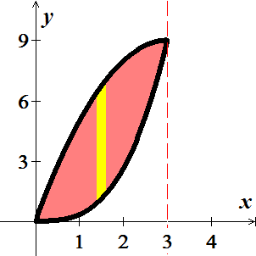 









***Exercise***

Use the disk method or shell method to find the volume of the solid generated vy revolving the region bounded by the graph of the equations about the given lines.



|  |  |  |
| --- | --- | --- |
|  |  |  |

***Solution***

1. Using ***Disk method***:



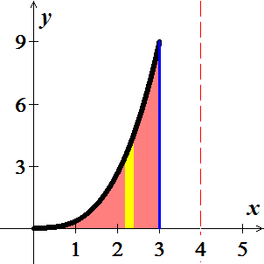 





1. Using ***Shell method***:



 







1. Using ***Shell method***:



 









***Exercise***

Use the disk method or shell method to find the volume of the solid generated vy revolving the region bounded by the graph of the equations about the given lines.



|  |  |  |
| --- | --- | --- |
|  |  |  |

***Solution***

1. Using ***Disk method***:



 







1. Using ***Shell method***:



 

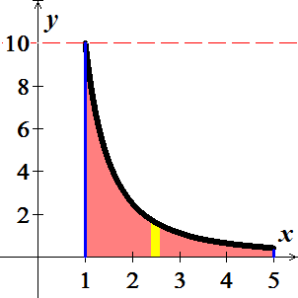 





1. Using ***Disk method***:



 













***Exercise***

Let  and  be the volumes of the solids that result when the plane region bounded by , , , and  is revolved about the  and the , respectively. Find the value of *c* for which 

***Solution***

 



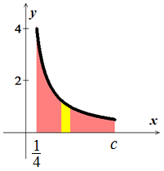 









Since 







 ( has no volume)

***Exercise***

The region bounded by , , and  is revolved about the  to form a paraboloid. A hole, centered along the axis of revolution, is drilled through this solid. The hole has a radius *k*, . Find the volume of the resulting ring

1. By integrating with respect to *x*
2. By integrating with respect to *y*.

***Solution***

1. 

  (***Shell Method***)

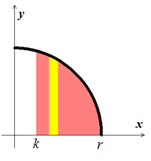 









1. 

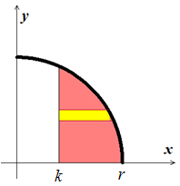

 







***Exercise***

The region *R* in the first quadrant bounded by the parabola  and the coordinate axes is revolved about the *y-*axis to produce a dome-shaped solid. Find the volume of the solid in the following ways.

1. Apply the disk method and integrate with respect to *y*.
2. Apply the shell method and integrate with respect to *x*.

***Solution***

1. 











1. 









***Exercise***

The region bounded by the curves , , and the line  is revolved about the *y-*axis. Find the volume of the resulting solid by

1. Integrating with respect to *x* and
2. Integrating with respect to *y*.

***Solution***

1. 







1. 



















***Exercise***

The region bounded by the graphs of , , and  in the first quadrant is revolved about the *y-*axis. What is the volume of the resulting solid?

***Solution***

























***Exercise***

The region bounded by  and the *x-*axis over the interval  is revolved about the *y-*axis. What is the volume of the solid that is generated?

***Solution***













***Exercise***

The region bounded by the graph  and the *x-*axis over the interval  is revolved about the line  . What is the volume of the solid that is generated?

***Solution***

Using *Shell* Method radius: 



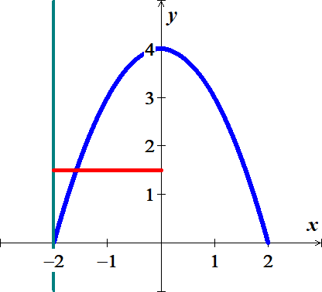 









***Exercise***

The region bounded by the graph  and  is revolved about the line  and the line . Find the volumes of the resulting solids. Which one is greater?

***Solution***

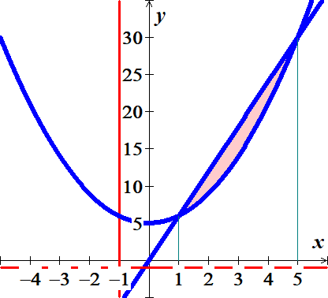



About 

Using *Washer* Method:



















About 

Using *Shell* Method:



















***Exercise***

The region bounded by the graph ,  and  is revolved about the line  and the line . Find the volumes of the resulting solids. Which one is greater?

***Solution***

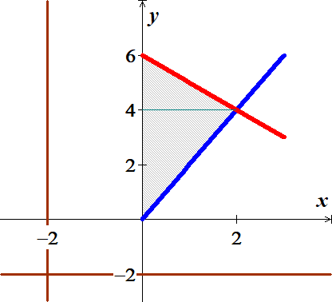



About 

Using *Shell* Method:















About 

Using *Washer* Method:















***Exercise***

The region *R* is bounded by the curves 

1. Write a single integral that gives the area of *R*.
2. Write a single integral that gives the volume of the solid generated when *R* is revolved about the *x-*axis.
3. Write a single integral that gives the volume of the solid generated when *R* is revolved about the *y-*axis.
4. Suppose *S* is a solid whose base is *R* and whose cross sections perpendicular to *R* and parallel to the *x-*axis are semicircles. Write a single integral that gives the volume of *S*.

***Solution***

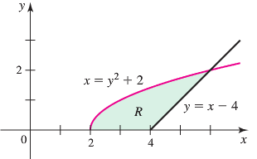



1. 
2. 
3. About *y-*axis:





1. 









***Exercise***

The region *R* is bounded by  and the *x-*axis on the interval , where  and .

Let  and  be the volumes of the solids generated when R is revolved about the *x-* and *y-*axes, respectively.

1. With  and , which is greater,  or ?
2. With  and , which is greater,  or ?
3. Find a general expression for in terms of *a* and *p*. Note that  is a special case, what is when ?
4. Find a general expression for in terms of *a* and *p*. Note that  is a special case, what is when ?
5. Explain how parts (*c*) and (*d*) demonstrate that 
6. Find any values of *a* and *p* for which 

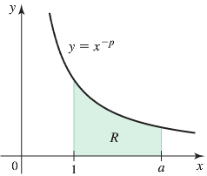***Solution***

1. 

















1. 





















1. 

For 







For 







∴ 

1. 



For 







For 







∴ 

1. From part (***c***):



Let 

















From part (***d***):



Let 















1. No,  always is greater than 



For 

***Exercise***

Let *R* be the region bounded by the graph of  and the  on . Find the positive value of *c* such that the volume of the solid generated by revolving *R* about the  equals the volume of the solid generated by revolving *R* about the .

***Solution***

About : (Using Disks)













About : (Using Shell)











***Exercise***

Find the volume of the torus (doughnut formed when the circle of radius 2 centered at (3, 0) is revolved about the *y-*axis.

1. Use geometry to evaluate the integral
2. 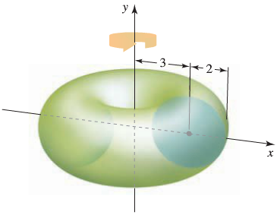Use Shell method (use integral table)

***Solution***











1.  is a semi-circle with center (0, 0) and radius = 2, and since 

Area = (Area of this circle)  



1. 





***Exercise***

The nose of a rocket is a solid of revolution of base radius *r* and height *h* that must join smoothly to the cylindrical body of the rocket. Taking the origin at the tip of the nose and the *x*-axis along the central axis of the rocket, various nose shapes can be obtained by revolving the cubic curve



about *x*-axis. The cubic curve must have slope 0 at *x* = *h*, and its slope must be positive for 0 < *x* < *h*. Find the particular cubic curve that maximizes the volume of the nose. Also show that his choice of the cubic makes the slope at the origin as large as possible and, hence, corresponds to the bluntest nose.

***Solution***

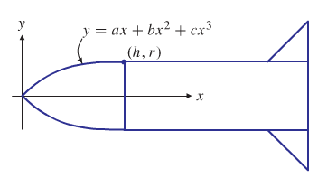



















The volume of the nose cone is then























Which is unacceptable since , and because  on .















If 

 



Hence, .

We have













The largest volume corresponds to , which is the largest allows value for a and so corresponds to the bluntest possible nose. The corresponding cubic  is







***Exercise***

A landscaper wants to create on level ground a ring-shaped pool having an outside radius of 10 *m* and a maximum depth of 1 *m* surrounding a hill that will be built up using all the earth excavated from the pool. She decided to use a fourth-degree polynomial to determine the cross-sectional shape of the hill and pool bottom: at distance ***r*** *m* from the center of the development the height above or below normal ground level will be



For some *a* > 0, where *k* is the inner radius of the pool.

Find *k* and *a* so that the requirements given above are all satisfied.

How much earth must be moved from the pool to build the hill?

***Solution***



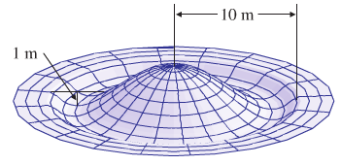 







Since the depth must be 1 *m*, then













Volume of the pool:











Volume of the hill:









Volume of the pool = Volume of the hill





















